How to Open a Shared Calendar

(This particular example shows how to open the Vacation Calendar) NOTE: The Leadership Team has been set up to have FULL ACCESS to the Vacation Calendar, meaning that members of the Team can make changes, delete and edit all information entered into the Vacation Calendar. Currently, while in testing mode, only the Leadership Team have access to this calendar.

- On the Calendar Tab, select “Open a Shared Calendar” on the left menu bar.

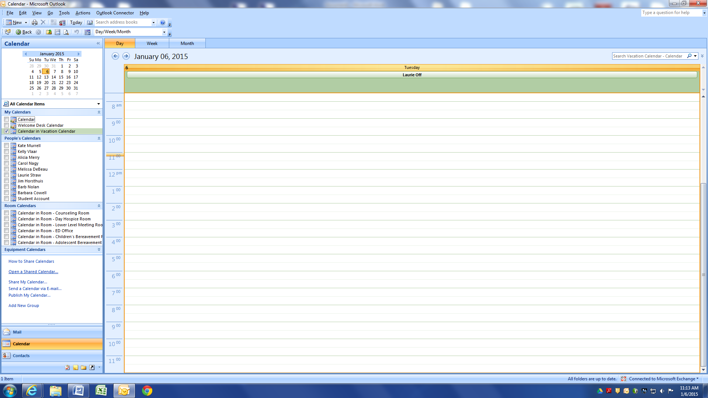

- Select “Name” on the menu box that appears to search for the Calendar for which you would like to gain access and view.

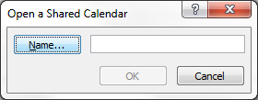

- Open the Contacts drop down menu and select “All Rooms” (to open Rooms or the Vacation Calendar specifically. To open the Equipment calendars or to share another individual’s calendar, select “Global Address List”
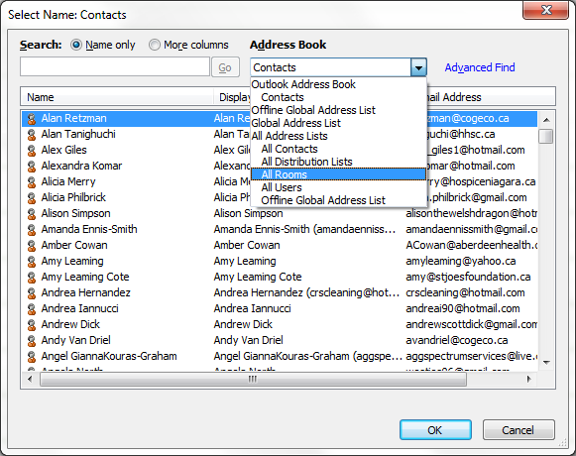

- Select your preferred Room Calendar (in this case, “Vacation Calendar”) and select OK. The room calendar will now appear with your list of calendars, and you will have access to view, edit and delete bookings.
